3 Stakeholders Analysis Diagrams
Name
Institution Affiliation

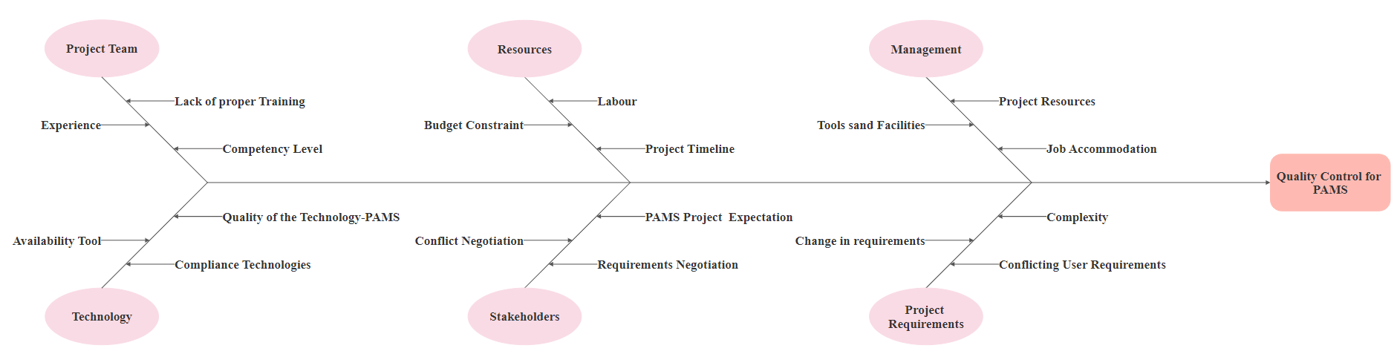
PAMS Stakeholders Fishbone Diagram
Figure 1 Stakeholder’s Fishbone Diagram
In the above Stakeholder’s Fishbone diagram, the assumption made include the following:
- Project Team Comprises not only the key stakeholders but also the those to implement the projects such as requirements analyst, requirements manager, application developers, system tester.
- Management is part of the stakeholder, and they will play part in project analysis process.
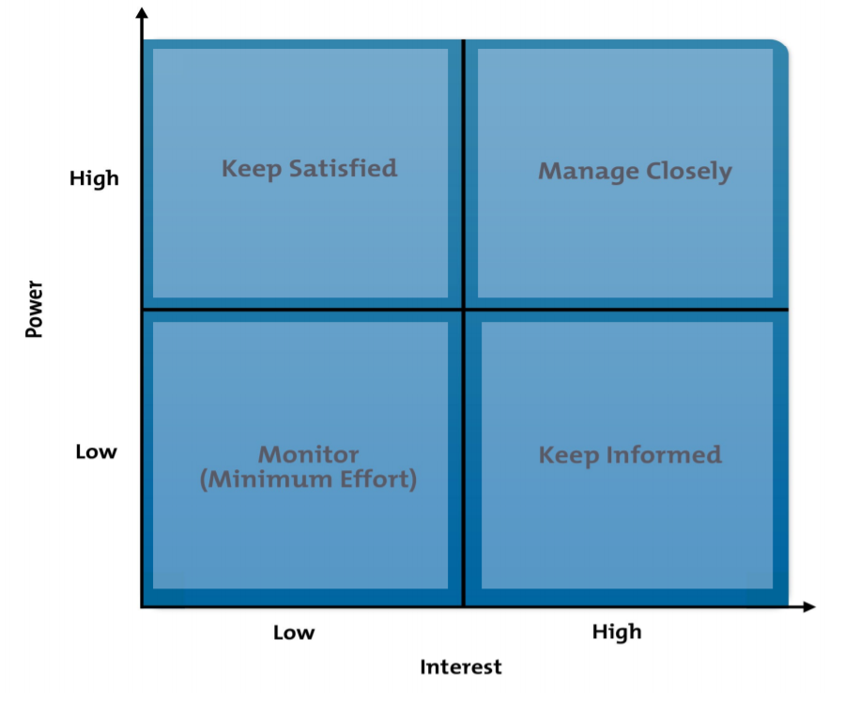
2. Power/ Influence Grid-PAMS
Figure 2: Power Influence Grid
In the above Power/ Influence Grid for PAMS, it provides an overview of the action to be taken with the stakeholders and the position to allocate them. Such positions include the following:
- High power, highly interested people (Manage Closely)- These are people to be fully engaged in the PAMS Project, and greatest efforts must be made to satisfy them. In this case, the high-power stakeholders include Library board, library directory, project manager, and customer.
- High power, less interested (Keep Satisfied)-This require putting enough work with these stakeholders to ensure they are satisfied. Such stakeholders in the Implementation of PAMS Library Project include Library Associate, Patron, and Library Supervisor.
- Low power highly interested (keep informed) In the implementation of PAMS Library Project, these stakeholders include the Development Team and Business Analyst.
- Low power, less interested people (monitor)-These stakeholders need to be monitored. For the Scootervile PAMS Library project, these stakeholders include Library Volunteers.

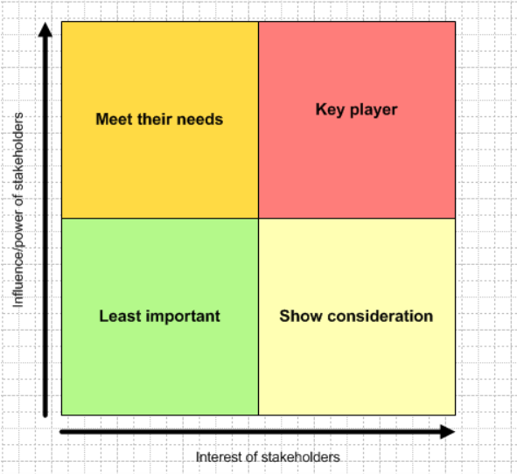
3. Stakeholder Matrix

Figure 3: Stakeholder Matrix
The above stakeholder matrix is an effective tool for analyzing the stakeholders. In this case, the stakeholders are divided against different criteria, which include meeting their needs, key player, least important, and show consideration. This forms part of understanding their needs and level of satisfaction needed in the implementation of Scootville PAMS Library Project

